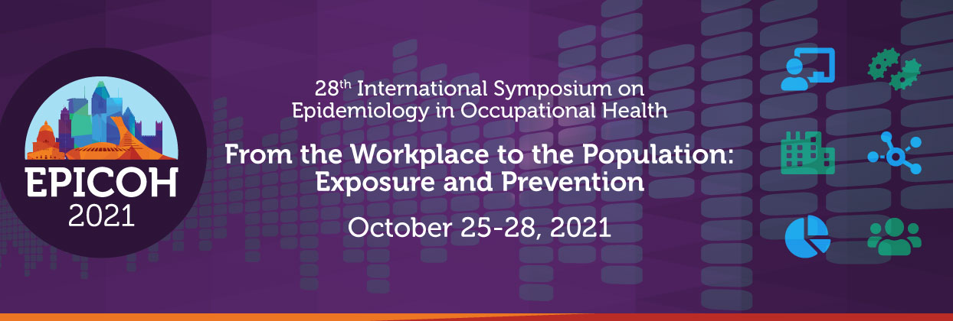

SYMPOSIA APPLICATION INSTRUCTIONS & FORM

The Organizing Committee of EPICOH 2021 invites participants interested in organizing a symposium to submit proposals on topics relevant to the conference theme. We welcome new proposals, as well as resubmissions from the postponed 2020 meeting. However, all proposals will be evaluated together to ensure coherence, and given the new virtual format for 2021, we anticipate that fewer proposals will be accepted.

Length: 90 minutes

Typical Structure for Symposia

- Short introductory remarks by the symposium organizer(s) / chair (s)
- A 15- to 20-minute talk by each speaker
- Panel discussion to conclude

Application Review Process for Submitted Symposia

The EPICOH 2021 Scientific Committee will review symposia proposals. Successful proposals should demonstrate relevance to the conference theme and diversity among the presenters (e.g., home institutions, good balance between established and new investigators, equitable representation).

Important Dates

- Symposia application forms should be submitted by April 15, 2021
- Notification of acceptance of symposia will be sent around the end of April
- Individual authors to submit their accepted symposium proposal as an abstract by May 15, 2021
- All symposia speakers must register to the conference by August 8, 2021 to confirm their presentation

Symposium organizers are asked to submit the following:

- Symposium title
- Symposium organizer(s) information (for each organizer)
  - Name, affiliation, email address, telephone, whether they are the chair or not
- Symposium abstract (approximately 500 words) comprised of a brief description of the symposium (including background and significance)
- Symposium presenters’ information (for each participant):
- Name
- Primary affiliation and email
- Confirmation of acceptance to speak at the symposium (yes/no)
- Brief description of the presentation (a few sentences). Formal abstracts will be submitted by individual presenters by May 15, 2021.

PLEASE SUBMIT COMPLETED FORMS TO THE ATTENTION OF LAURA BEANE FREEMAN: freemala@mail.nih.gov

SYMPOSIA APPLICATION FORM
Deadline for submission: April 15, 2021

SYMPOSIUM TITLE

SYMPOSIUM ORGANIZERS INFORMATION

Full Name | Affiliation | Email | Telephone | Is this person the chair? (Yes or No)

SYMPOSIUM ABSTRACT (approximately 500 words)
Include a brief description of the symposium including background and significance

SYMPOSIUM PRESENTER INFORMATION

# | Full Name | Affiliation | Email | Presenter Accepted  (Yes or No)
1

2

3

4

5

BRIEF DESCRIPTION OF PRESENTATIONS

# | Description
1

2

3

4

5

